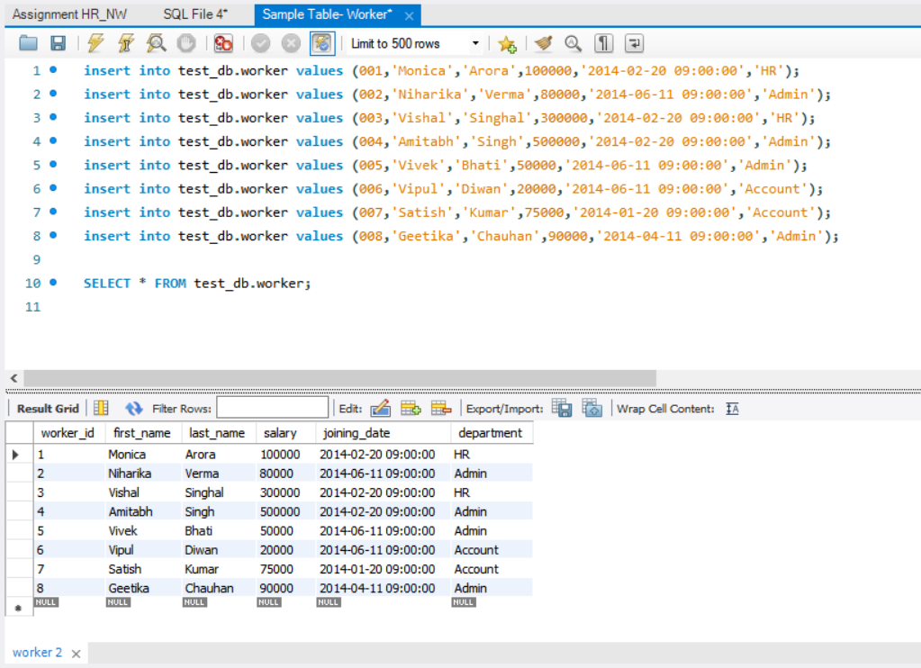

1. Write an SQL query to fetch “FIRST_NAME” from Worker table using the alias name as

<WORKER_NAME>.

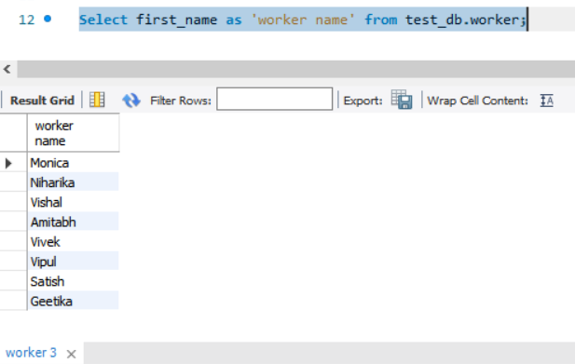

2. Write an SQL query to fetch “FIRST_NAME” from Worker table in uppercase.

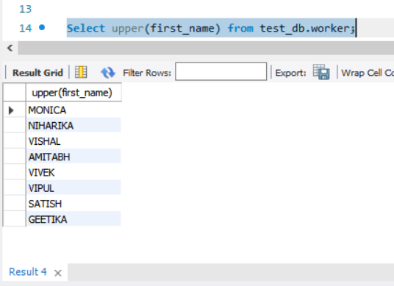

3. Write an SQL query to fetch unique values of DEPARTMENT from Worker table.

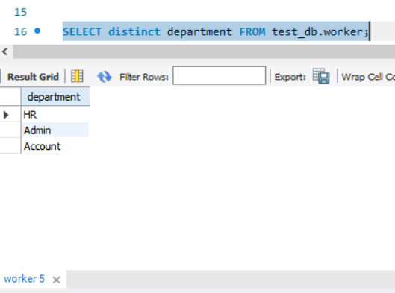

4. Write an SQL query to print the first three characters of FIRST_NAME from Worker table.

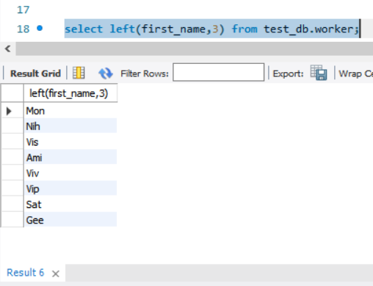

5. Write an SQL query to find the position of the alphabet (‘a’) in the first name column

‘Amitabh’ from Worker table.

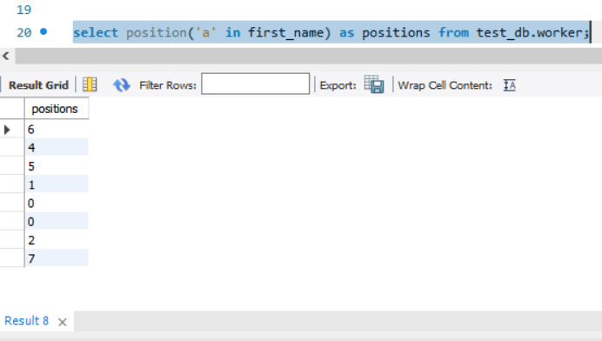

6. Write an SQL query to print the FIRST_NAME from Worker table after removing white

spaces from the right side.

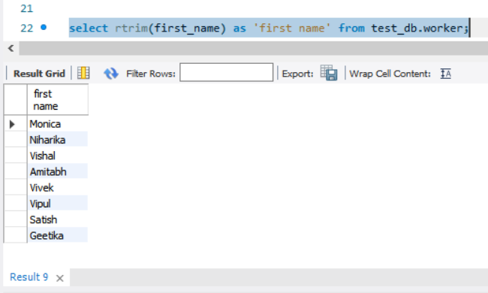

7. Write an SQL query to print the DEPARTMENT from Worker table after removing white

spaces from the left side.

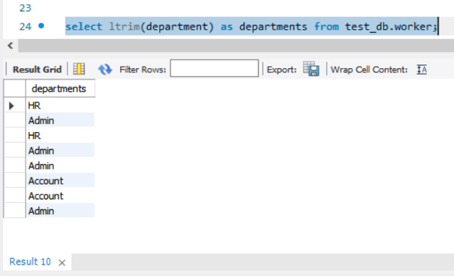

8. Write an SQL query that fetches the unique values of DEPARTMENT from Worker table

and prints its length.

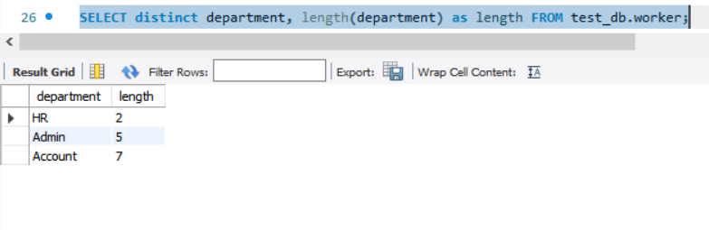

9. Write an SQL query to print the FIRST_NAME from Worker table after replacing ‘a’ with

‘A’.

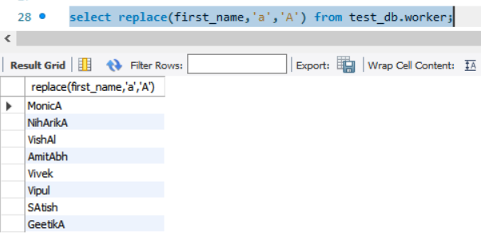10. Write an SQL query to print the FIRST_NAME and LAST_NAME from Worker table into a

single column COMPLETE_NAME. A space char should separate them.

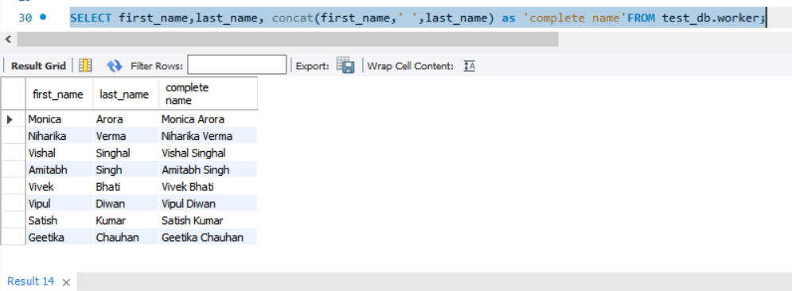

11. Write an SQL query to print all Worker details from the Worker table order by

FIRST_NAME Ascending.

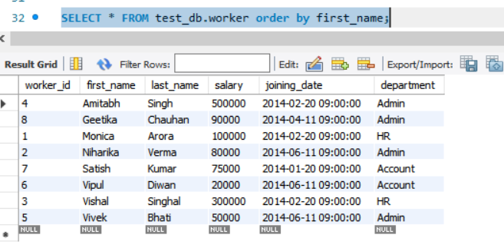

12. Write an SQL query to print all Worker details from the Worker table order by

FIRST_NAME Ascending and DEPARTMENT Descending.

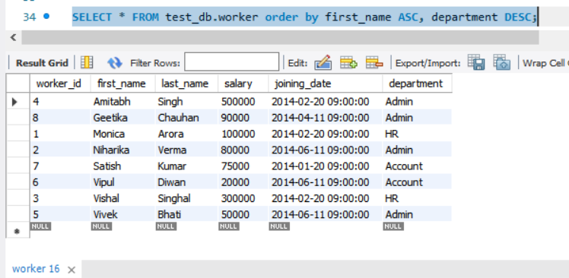

13. Write an SQL query to print details for Workers with the first name as “Vipul” and

“Satish” from Worker table.

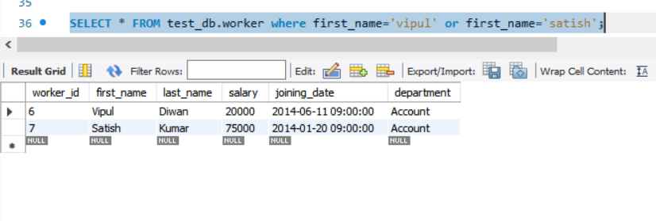

14. Write an SQL query to print details of workers excluding first names, “Vipul” and

“Satish” from Worker table.

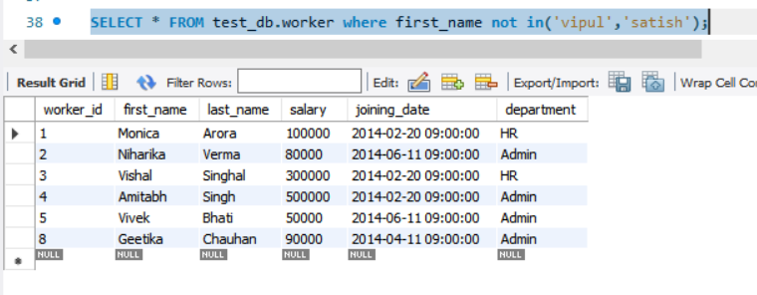

15. Write an SQL query to print details of Workers with DEPARTMENT name as “Admin”.

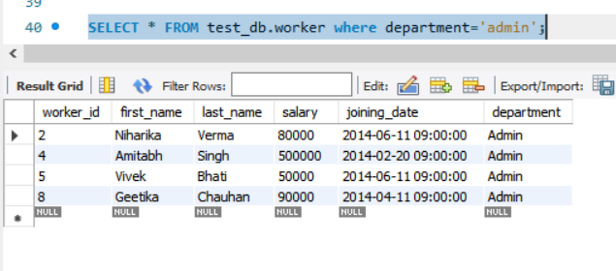

16. Write an SQL query to print details of the Workers whose FIRST_NAME contains ‘a’.

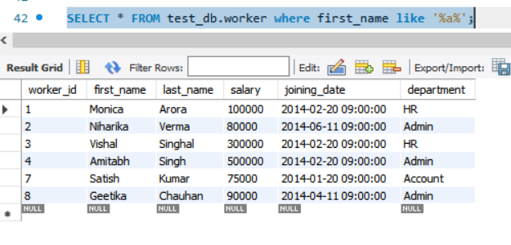

17. Write an SQL query to print details of the Workers whose FIRST_NAME ends with ‘a’

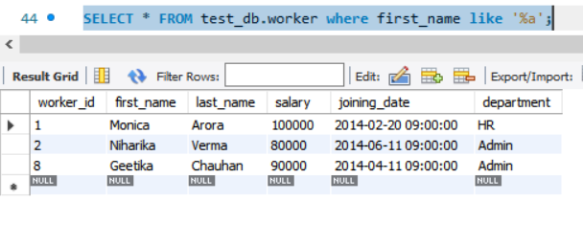

18. Write an SQL query to print details of the Workers whose FIRST_NAME ends with ‘h’ and

contains six alphabets.

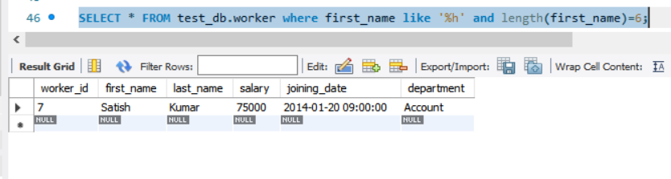

19. Write an SQL query to print details of the Workers whose SALARY lies between 100000

and 500000.

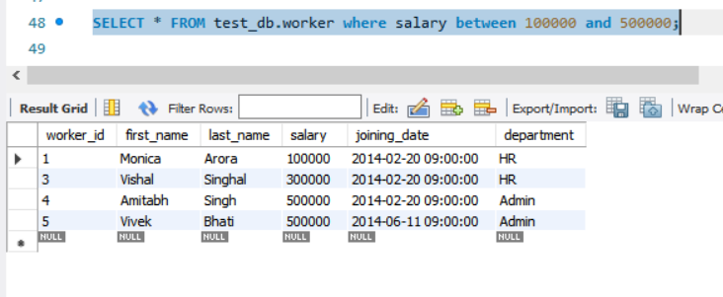

20. Write an SQL query to print details of the Workers who have joined inFeb’2014.

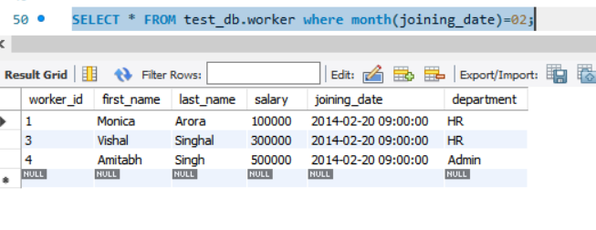

21. Write an SQL query to fetch the count of employees working in the department

‘Admin’.

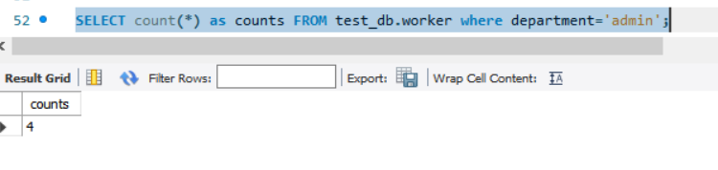

22. Write an SQL query to fetch worker names with salaries >= 50000 and <= 100000.

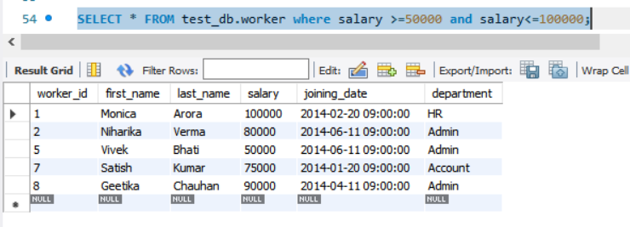

23. Write an SQL query to fetch the no. of workers for each department in the

descending order.

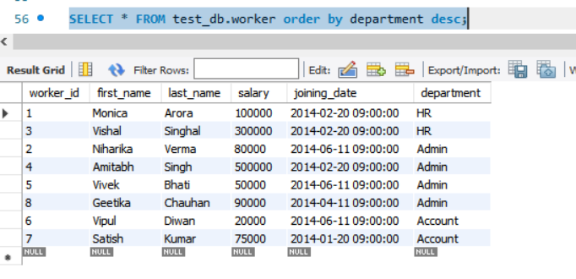

24. Write an SQL query to show only odd rows from the table.

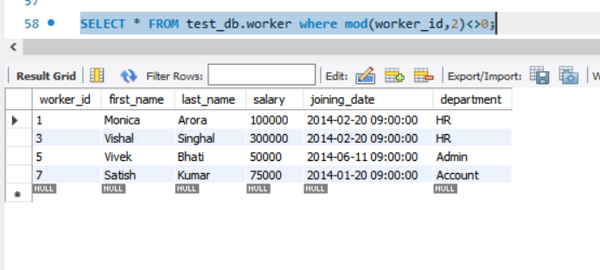

25. Write an SQL query to show the top 10 records of the table in terms of salary.

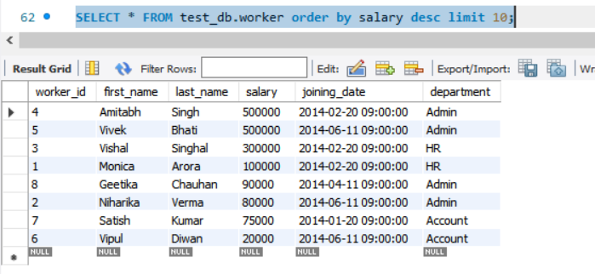

26. Write an SQL query to fetch the list of employees with the same salary.

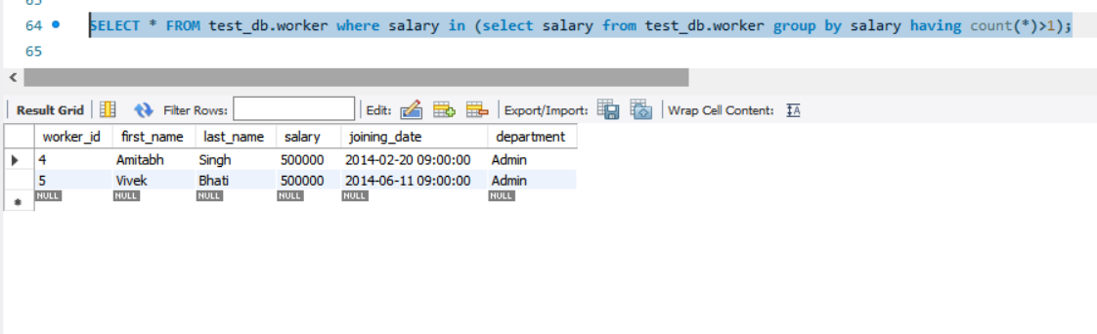

27. Write an SQL query to show the second highest salary from a table.

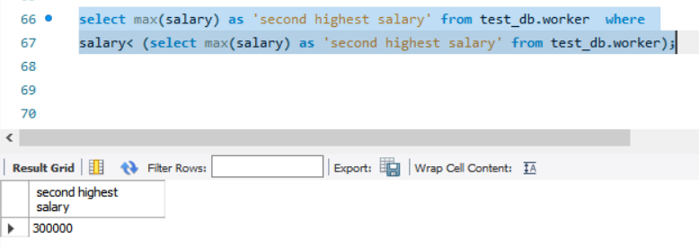

28. Write an SQL query to fetch the departments that have less than five people in it.

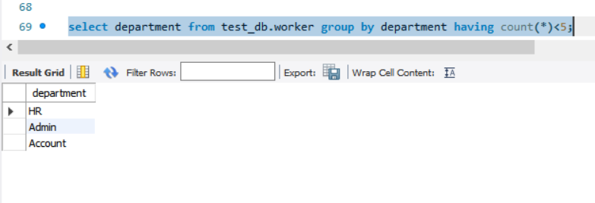

29. Write an SQL query to show all departments along with the number of people in

there.

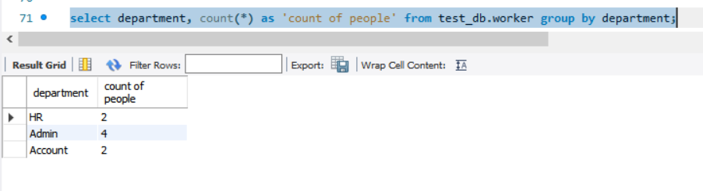

30. Write an SQL query to show the last record from a table.

